**LAMPIRAN B**

**CDM DAN PDM**

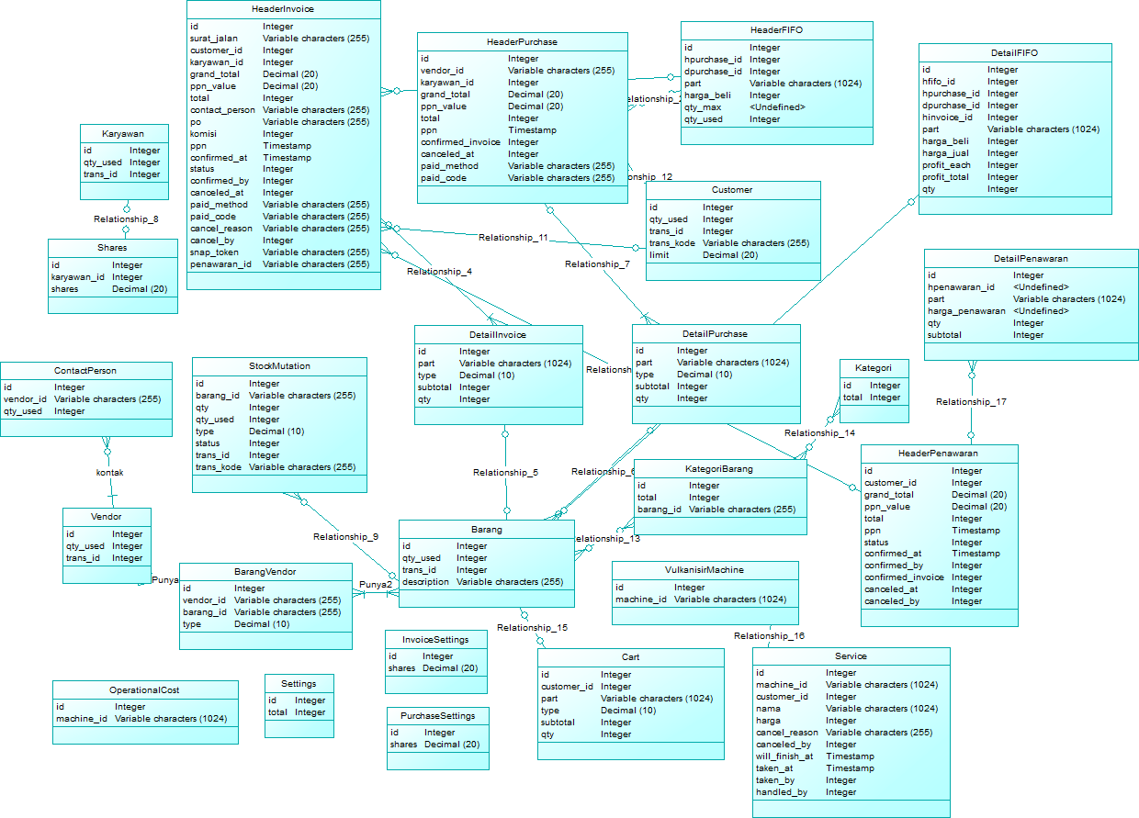

**Gambar B.1**

**CDM (Conceptual Data Model**

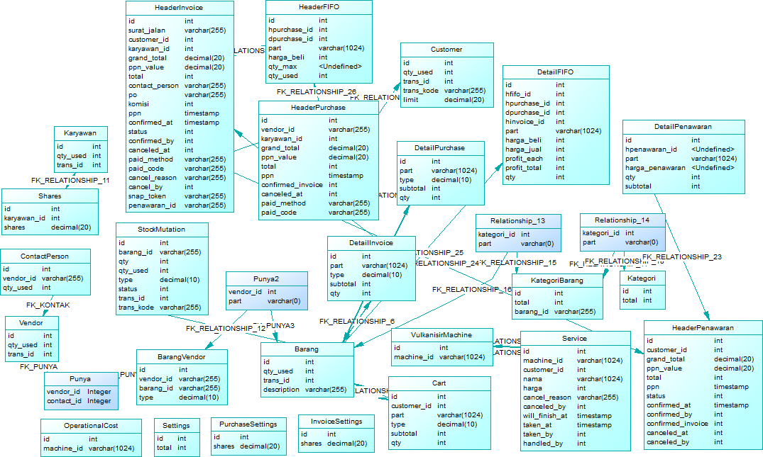

**Gambar B.2**

**PDM (Physical) Data Model**